COLLEGE OF ENGINEERING AND COMPUTER STUDIES

OUTCOMES EVALUATION 4

A Culinary Adventure

ITCL – Introduction to Computing Lab
4004

Submitted By
John William C. Togonon

Course & Section
CS 1-1

Date
20/09/2026

TABLE OF CONTENTS

- INTRODUCTION

- Problem Description

- Learning Objectives

- DESIGN AND IMPLEMENTATION

A. Project Structure

B. Webpage Design

C. Program Implementation

- RESULTS AND DISCUSSION

- REFLECTION

- REFERENCES

INTRODUCTION

Problem Description
A Culinary Adventure is a single-page website about four dishes from the Philippines, Japan, Mexico, and India. Each slide combines a food image, a short description, and three quick facts. Visitors can browse the dishes without leaving the page.

Learning Objectives
The project demonstrates how HTML organizes content, CSS controls its appearance, and JavaScript changes what visitors see. It also provides simple navigation by menu, Next button, mouse wheel, and touch swipe.

DESIGN AND IMPLEMENTATION

A. Project Structure
The OE4 folder contains index.html for page content, style.css for colors and layout, script.js for slide navigation, and img/ for food pictures. The page can be opened directly in a web browser.

B. Webpage Design
Each dish has a full-screen slide with a large picture, title, description, and details. A fixed header shows the cuisine choices and a slide counter. On narrow screens, the layout places the text below the image and hides the header menu.

C. Program Implementation
HTML Structure. The HTML file defines four dish sections and places the cuisine buttons, counter, and Next button outside them. Each section contains an image, title, description, and quick facts.

CSS Styling. The style sheet removes default spacing and sets the site's fonts and colors. Each slide fills the screen; inactive slides are hidden with opacity and visibility, while the active slide fades into view. A fixed header and Next button stay in place during navigation. Flexbox places the large food image beside the information, and each cuisine has its own background color. The 700px media query hides the menu and rearranges the image and text for phones.

JavaScript Functionality. The script stores the current slide number and selects the slide, menu button, and counter elements. showSlide removes active from the old slide and button, adds it to the new pair, and updates the counter. nextSlide uses modulo so the fourth slide returns to the first. Wheel and touch listeners detect direction and call moveSlideByGesture, which waits 600 milliseconds between gesture changes to prevent skipped slides.

RESULTS AND DISCUSSION
The page opens on Pork Adobo as slide 1 of 4. The cuisine buttons, Next button, mouse wheel, and touch swipe all change the active slide and update the counter. Pressing Next on the fourth slide returns to the first slide.
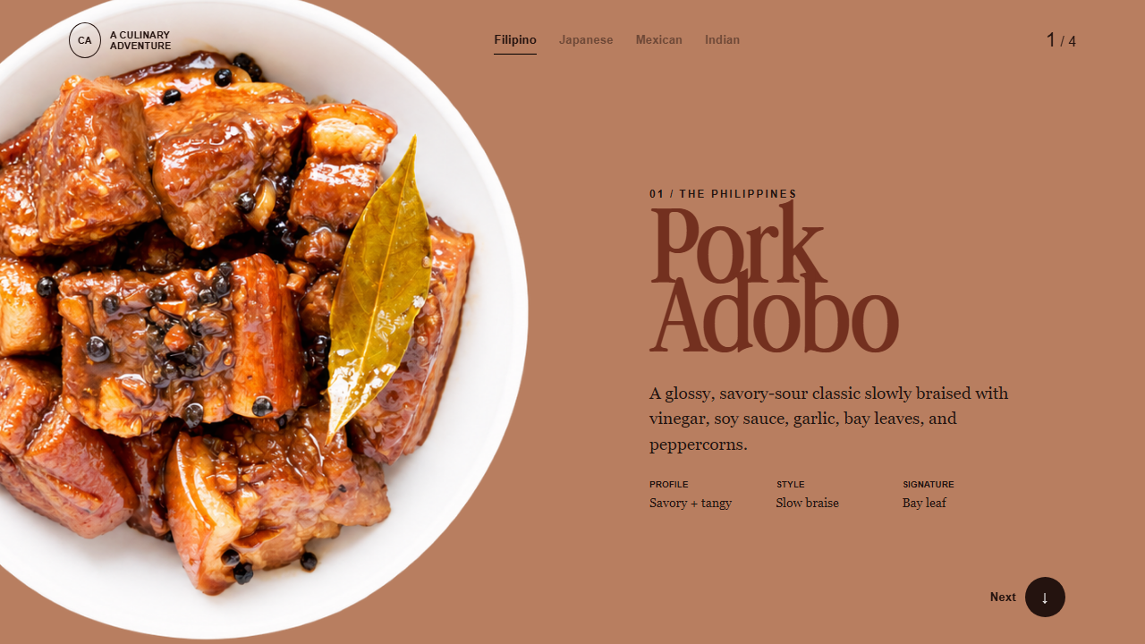
Figure 1. The first slide presents Filipino Pork Adobo with its description and quick facts.

REFLECTION
This project shows how a small website can keep content, visual design, and interaction in separate files. The four-slide layout makes the dishes easy to compare and browse.

REFERENCES
Project files in the OE4 folder: index.html, style.css, script.js, and img/.

